Computer Networks
CSE 325
Lab Assignment - 2

Gyanendra Shukla
CSE - 1
Scholar Number: 191112040



MAULANA AZAD
NATIONAL INSTITUTE OF TECHNOLOGY
BHOPAL – 462 003 (INDIA)
January 2022

Contents

1. Ping Command: 3
2. GETMAC: 4
3. IPCONFIG: 4
4. ARP 5
5. HOSTNAME: 5
6. NSLOOKUP: 6
7. NBSTAT: 6
8. NET: 7
9. NETSTAT: 7
10. NETSH: 8
11. TASKLIST: 8
12. TASKKILL: 9
13. TRACERT: 9
14. PATHPING: 10
15. SYSTEMINFO: 10

Basic commands in Computer Networking

Ping Command:

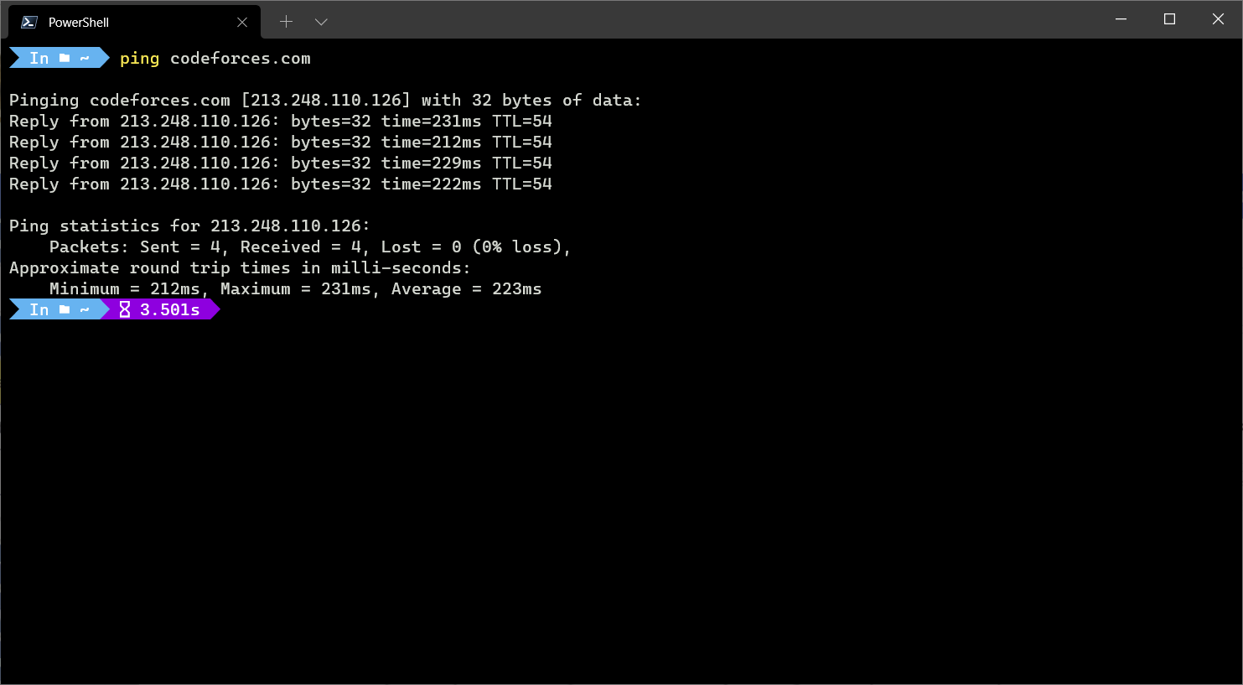

We can use the ping command to test whether or not we can make contact with another network device. It could be a device on our network (for instance, our network router) or to a website domain or internet IP address to test our internet connectivity.

GETMAC:
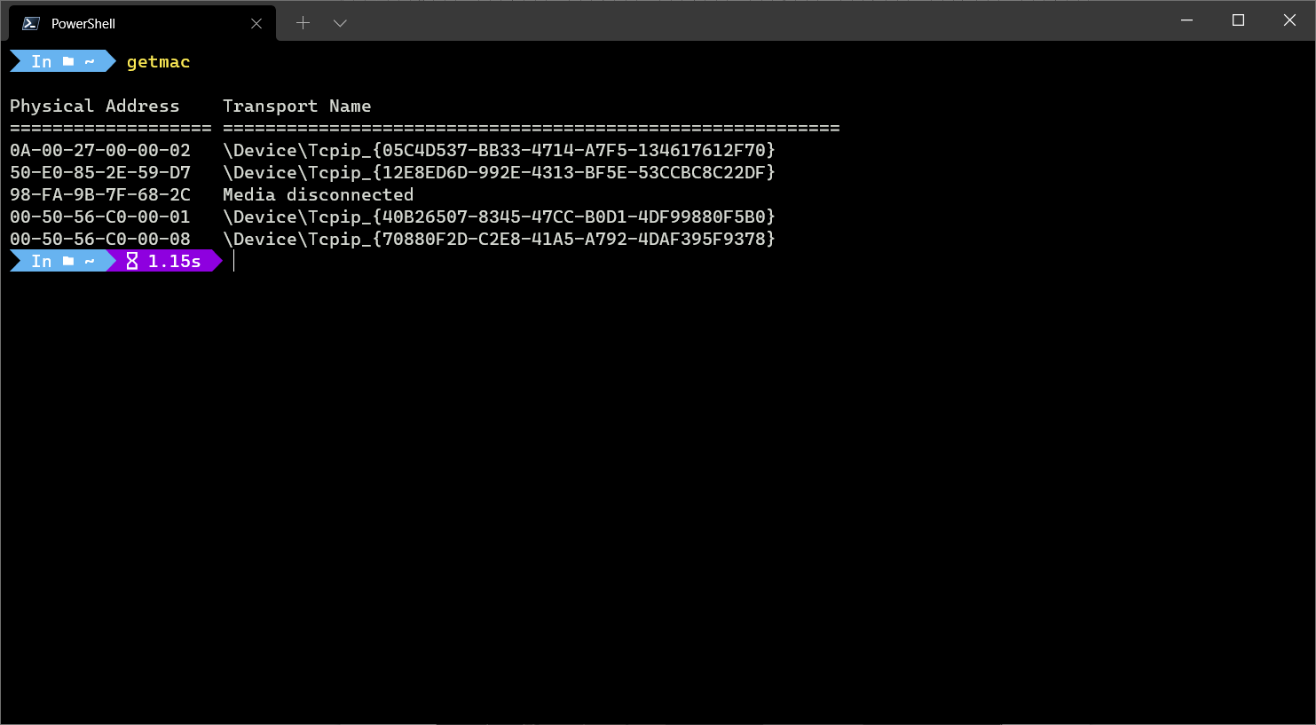
We use the getmac command o find the MAC address of the devices connected.

IPCONFIG:
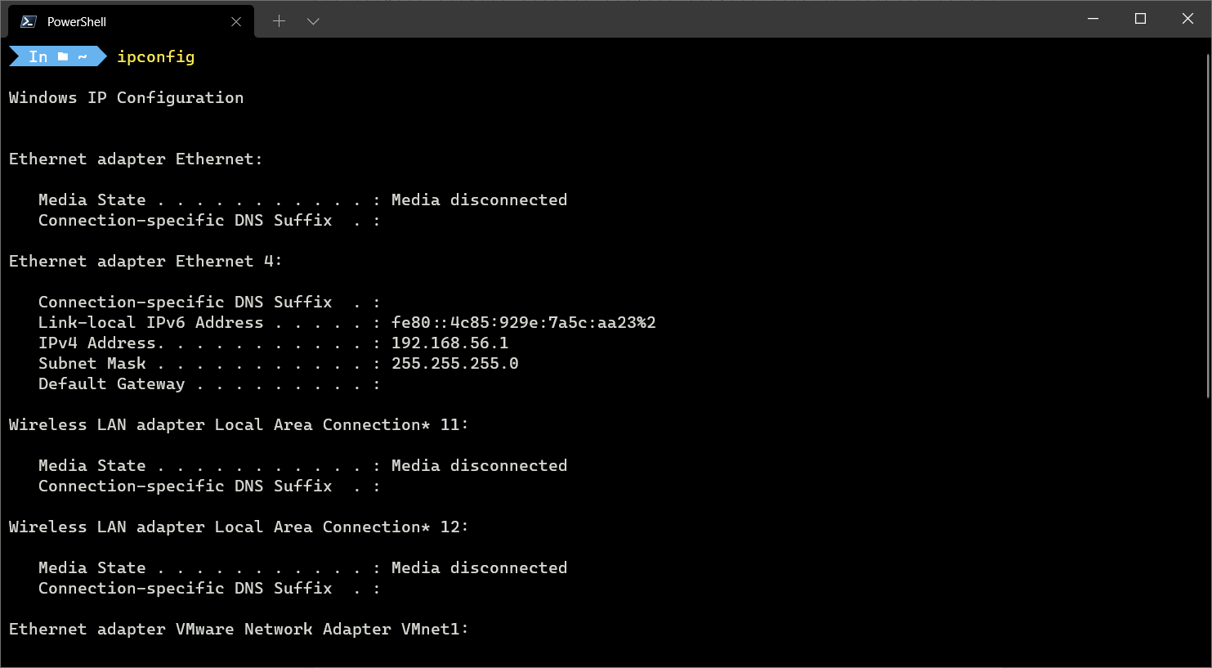
Typing ipconfig at the terminal will list all available commands, but these include:
- To view your current network IP address:
ipconfig getifaddr deviceid
- To view your current network DNS server:
ipconfig getoption deviceid domain_name_server

ARP
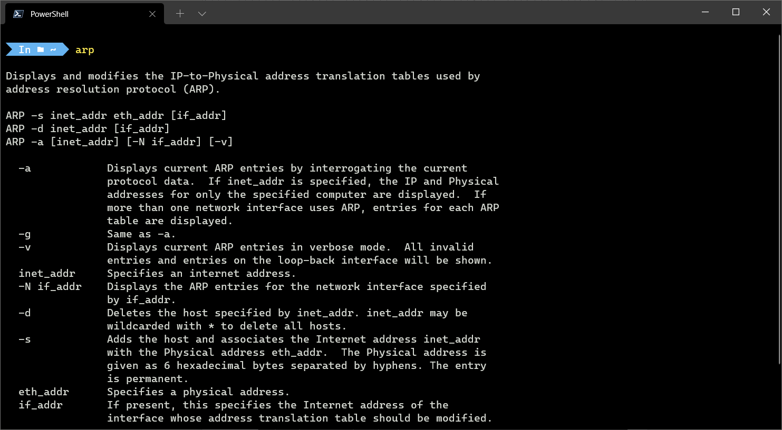
If you want to view a list of all active devices on a local network, you could use the arp tool. This will list the IP and MAC addresses for any devices that your Mac has detected on your network, based on the ARP (Address Resolution Protocol) broadcasts those devices have made.

HOSTNAME:
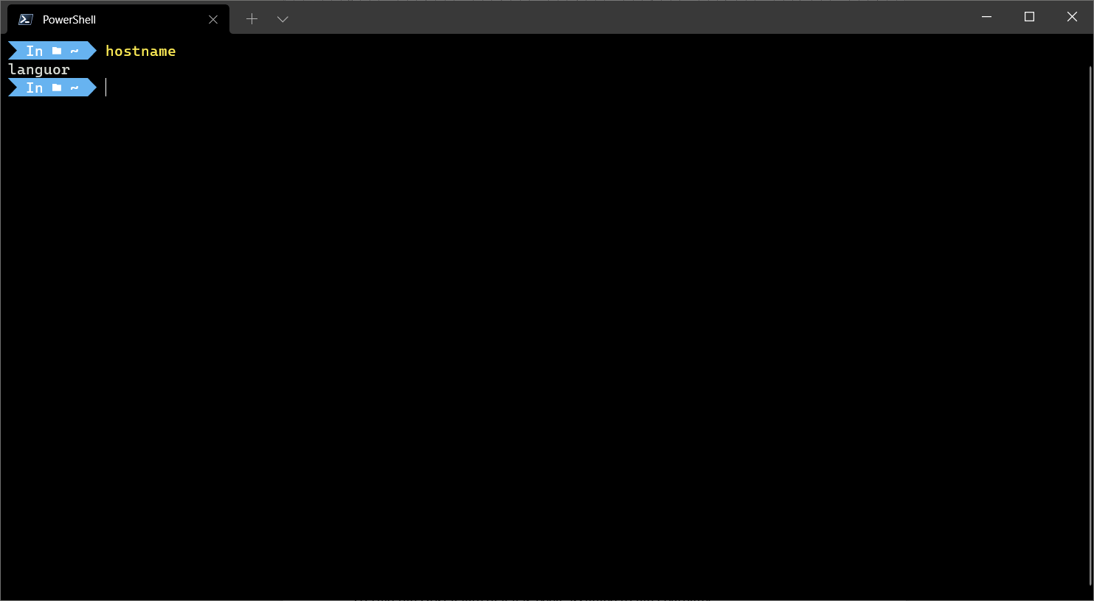
To find the Host name that has been assigned to the computer.

NSLOOKUP:
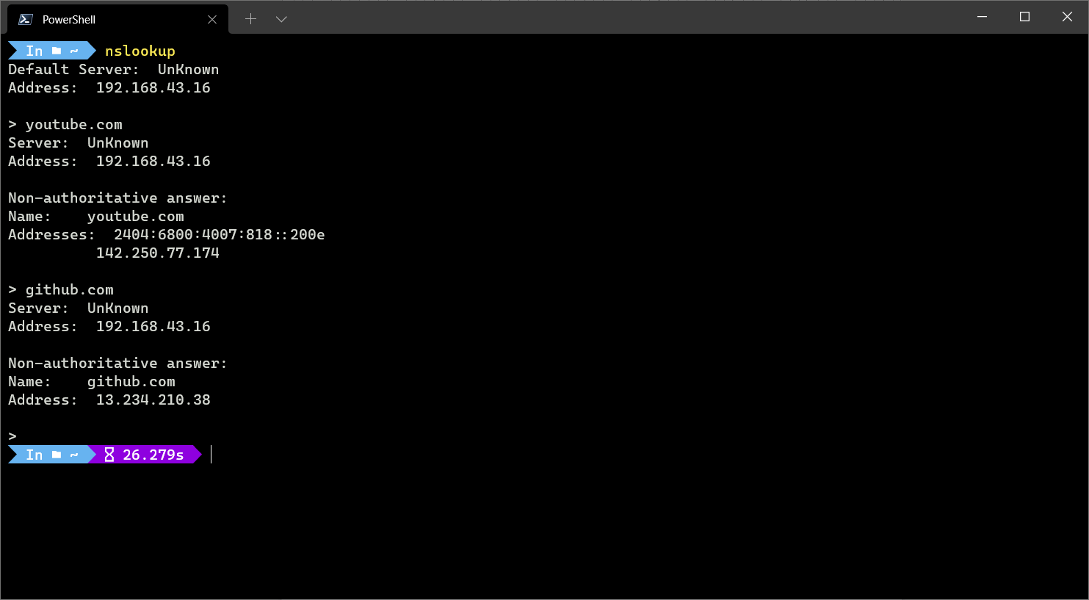
The nslookup, which stands for name server lookup command, is a network utility command used to obtain information about internet servers. It provides name server information for the DNS (Domain Name System), i.e. the default DNS server’s name and IP Address.

NBSTAT:
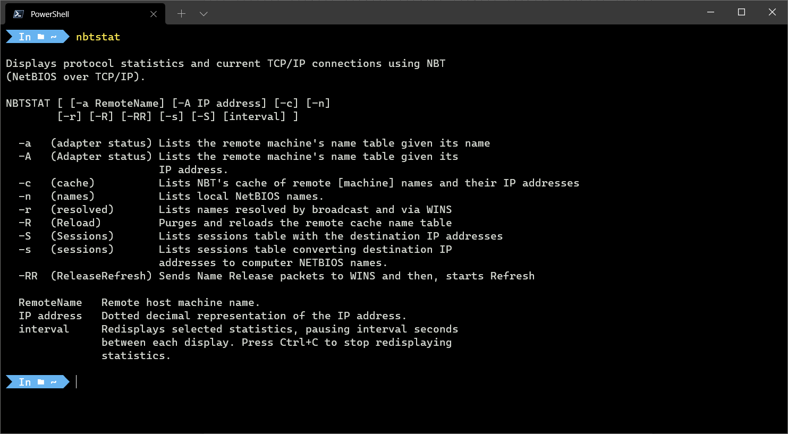
nbtstat command is used to help you diagnose and resolve these problems.

NET:
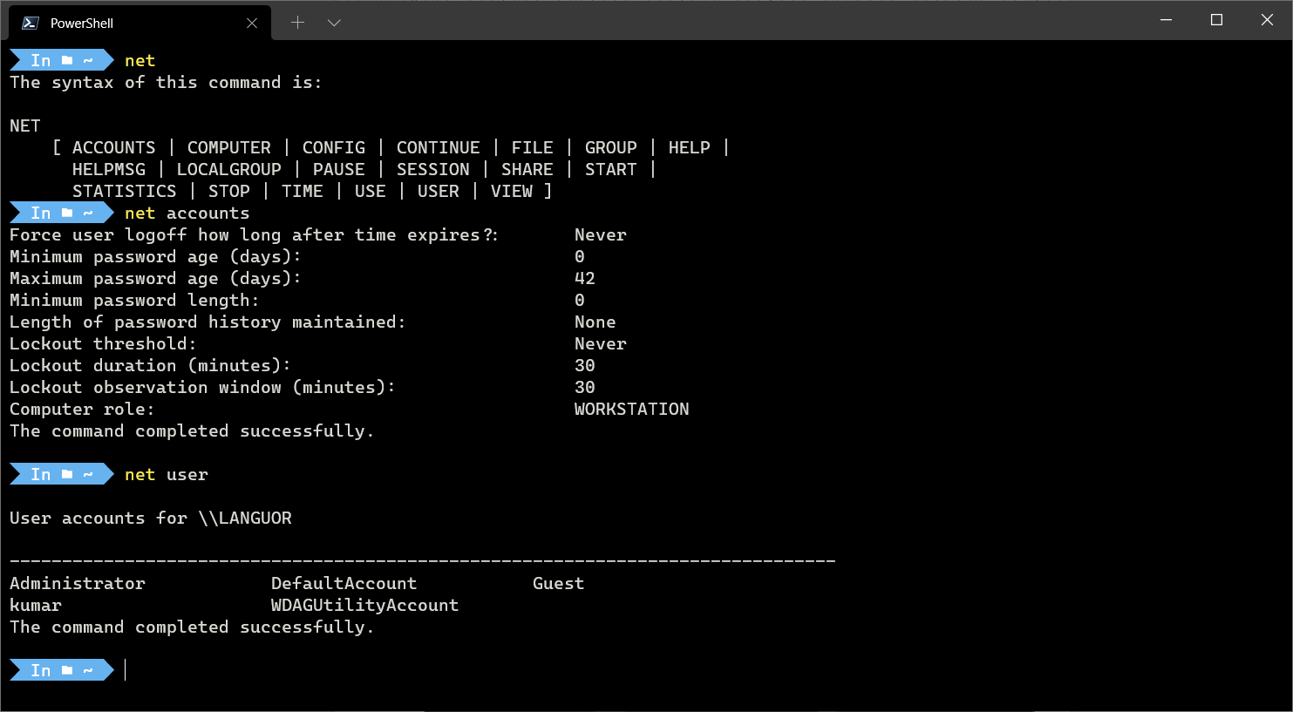
Used to manage many different aspects of a network and its settings such as network shares, users and print jobs.

NETSTAT:
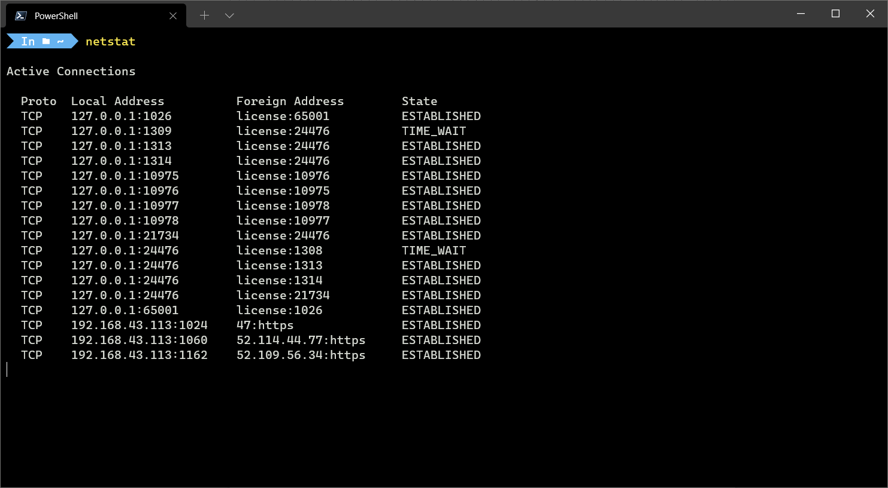
It shows the useful network summary for your device.

NETSH:
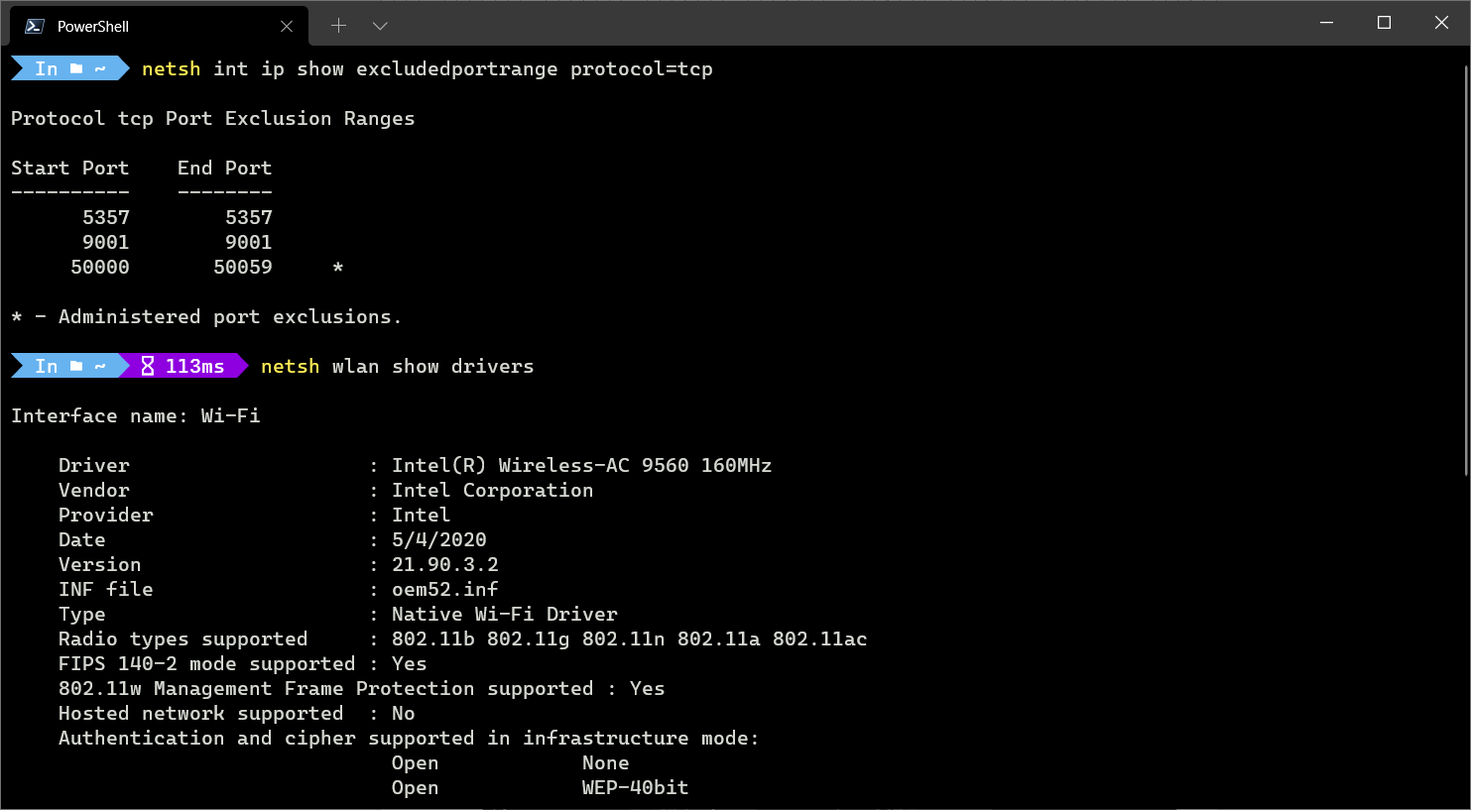
Used to view and configure almost all of the network adapters in your device in much greater detail compared with some other commands.

TASKLIST:
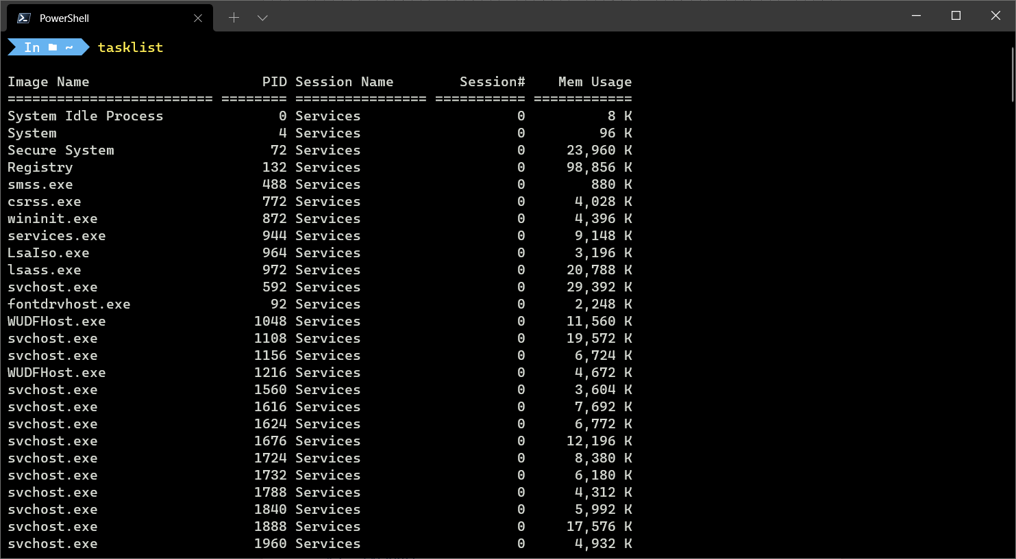
It will show all the running processes and their process id(PID).

TASKKILL:
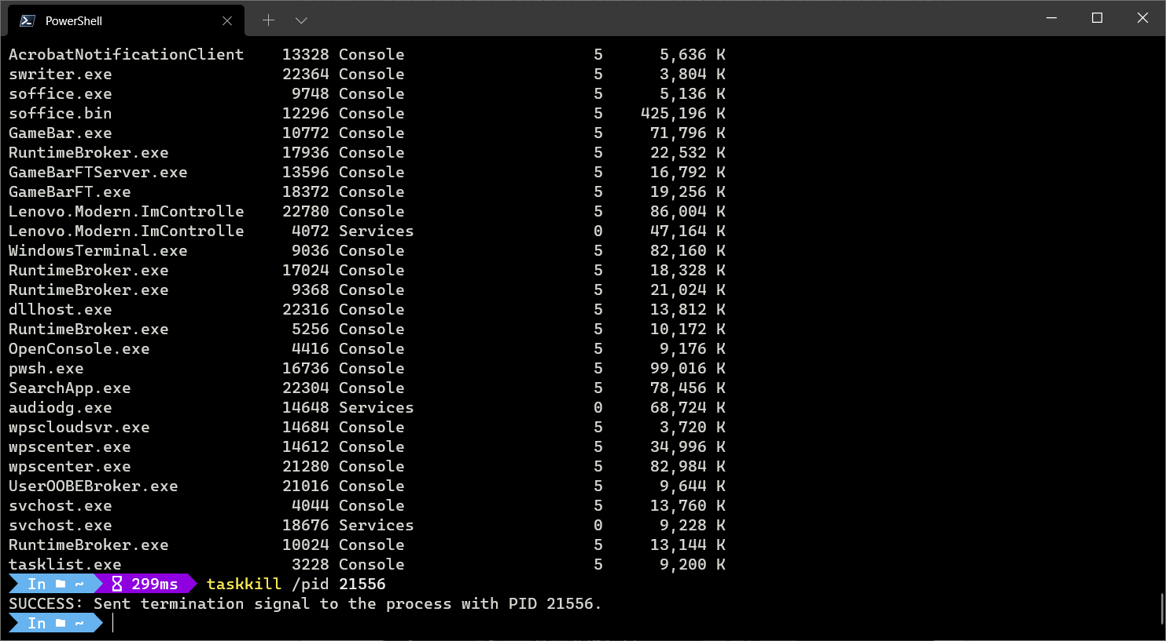
It is used to kill the task by name of its PID provided by TASKLIST command.

TRACERT:
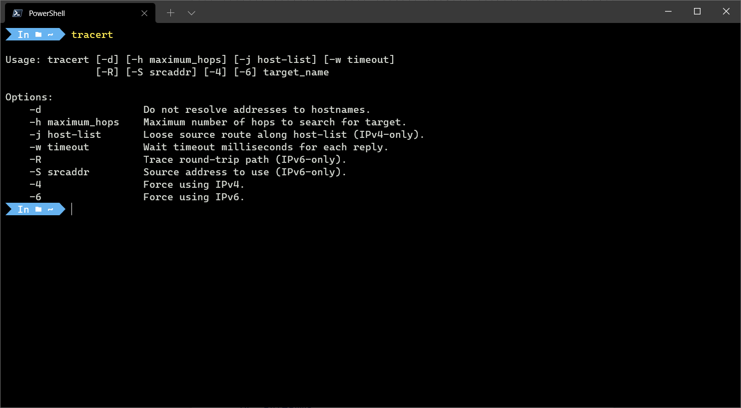
By using the tracert command you can trace the route a packet takes before reaching its destination, and see information on each “hop” along the route.

PATHPING:
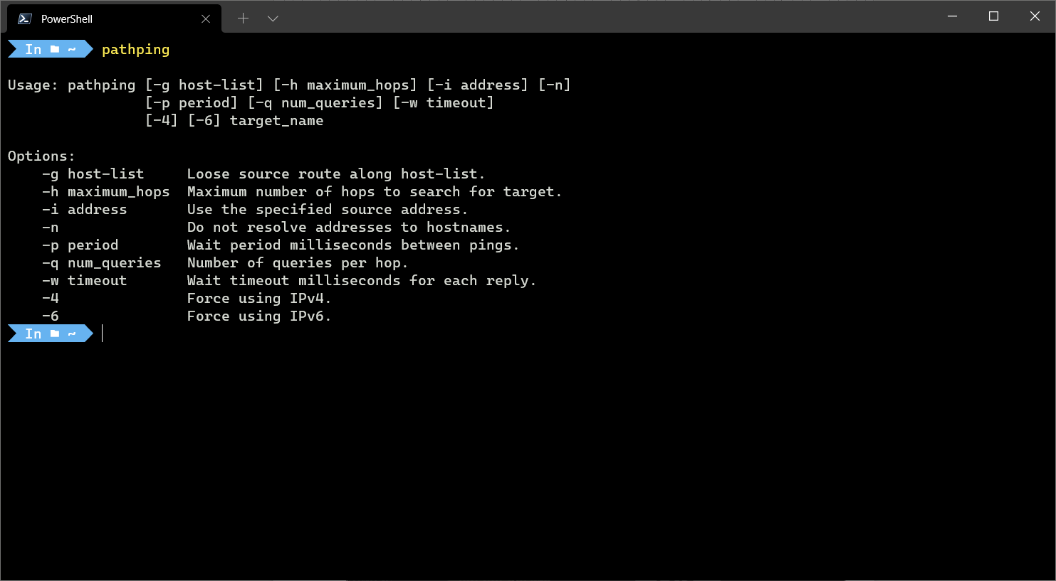
It combines that best of both ping and tracert into a single utility.

SYSTEMINFO:
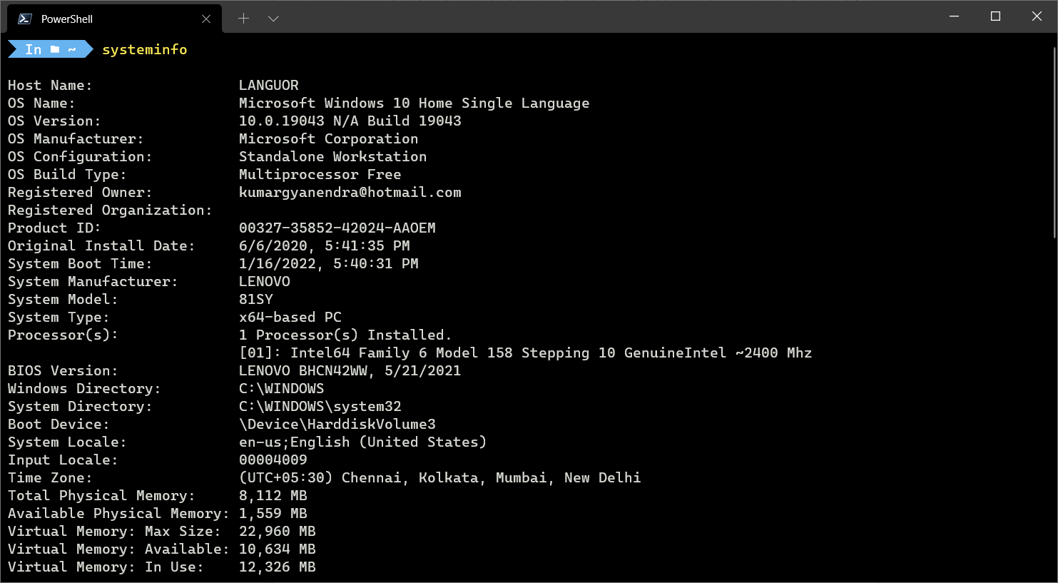
It shows the details of the processor used, the version of Windows, or what the boot device is configured as.

